Romeo & Juliet, Act 3 Scene 1 nomen/name:
View the scene and read the quotes, then answer the questions.
- How would you describe Romeo’s mood, based on his words?
- How would you describe Tybalt’s mood, based on his words?
- Which man in the picture do you think is Tybalt?
- What about the actor’s pose and body language makes you think that?

Romeo & Juliet, Act 3 Scene 1 nomen/name:
View the scene and read the quotes, then answer the questions.
- How would you describe Romeo’s mood, based on his words?
- How would you describe Tybalt’s mood, based on his words?
- Which man in the picture do you think is Tybalt?
- What about the actor’s pose and body language makes you think that?

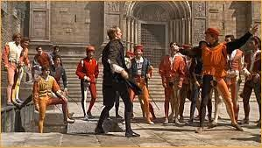
Tybalt: Romeo, the hate I bear thee can afford no better term than this, thou art a villain.
Romeo: Tybalt, the reason that I have to love thee doth much excuse the appertaining rage to such a greeting. Villain am I none, therefore, farewell, I see thou know’st me not.
Tybalt: Boy this shall not excuse the injuries that thou hast done me, therefore turn and draw.

Roman theater:
- List 3 sterotype characters
- Name 1 common plot device in a comedy.
- Name 1 common plot device in a tragedy.
- What modern play or show do you think Romans would enjoy?

Roman theater:
- List 3 sterotype characters
- Name 1 common plot device in a comedy.
- Name 1 common plot device in a tragedy.
- What modern play or show do you think Romans would enjoy?

